Write a Python Code For Blinked LED And Traffic Lights In Raspberry Pi
Assignment-3

By
P.MARITHURAICHI
952319104028

Write a code for Blinked LED and Traffic Lights in Raspberry Pi

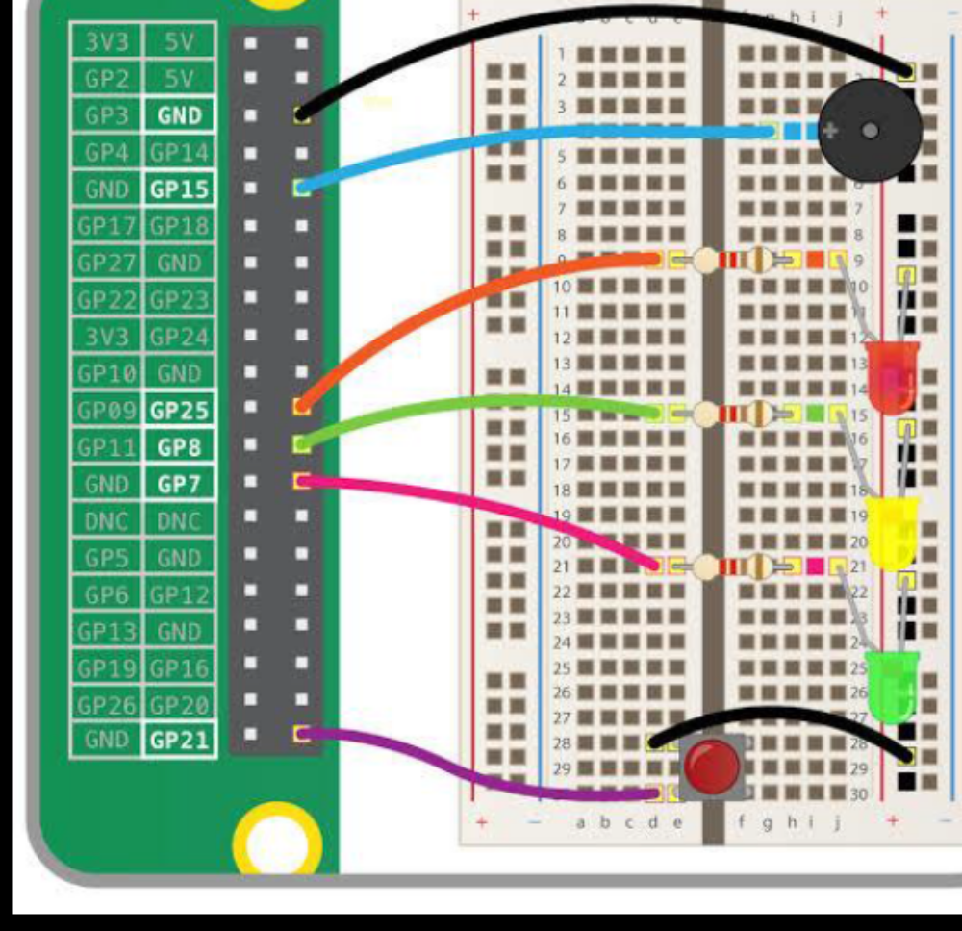

Coding for Blinked LED
Import RPi.GPIO as GPIO # RPi.GPIO can be referred as GPIO from now
Import time
ledPin = 22 # pin22
def setup():
GPIO.setmode(GPIO.BOARD) # GPIO Numbering of Pins
GPIO.setup(ledPin, GPIO.OUT) # Set ledPin as output
GPIO.output(ledPin, GPIO.LOW) # Set ledPin to LOW to turn Off the LED
Def loop():
While True:
Print ‘LED on’
GPIO.output(ledPin, GPIO.HIGH) # LED On
Time.sleep(1.0) # wait 1 sec
Print ‘LED off’
GPIO.output(ledPin, GPIO.LOW) # LED Off
Time.sleep(1.0) # wait 1 sec
Def endprogram():
GPIO.output(ledPin, GPIO.LOW) # LED Off
GPIO.cleanup() # Release resources
If __name__ == ‘__main__’: # Program starts from here
Setup()
Try:
Loop()
Light Except KeyboardInterrupt: # When ‘Ctrl+C’ is pressed, the destroy() will be executed
Endprogram()
Coding for Traffic lights
From gpiozero import LED
From time import sleep
Green = LED(17)
Yellow = LED(27)
Red = LED(22)
Def switchLights (greenLight, yellowLight, redLight, sleepTime):
If greenLight:
Green.on()
Else:
Green.off()
If yellowLight:
Yellow.on()
Else:
Yellow.off()
If redLight:
Red.on()
Else:
Red.off()
Sleep(sleepTime)
While True:
switchLights (True, False, False, 10)
switchLights (False, True, False, 1)
switchLights (False, False, True, 10)
switchLights (False, True, True, 1)

